ANUKEERTHANA S

Module 3 - PL/SQL Programming
Exercise – 03
Stored Procedures
Scenario 1: Process Monthly Interest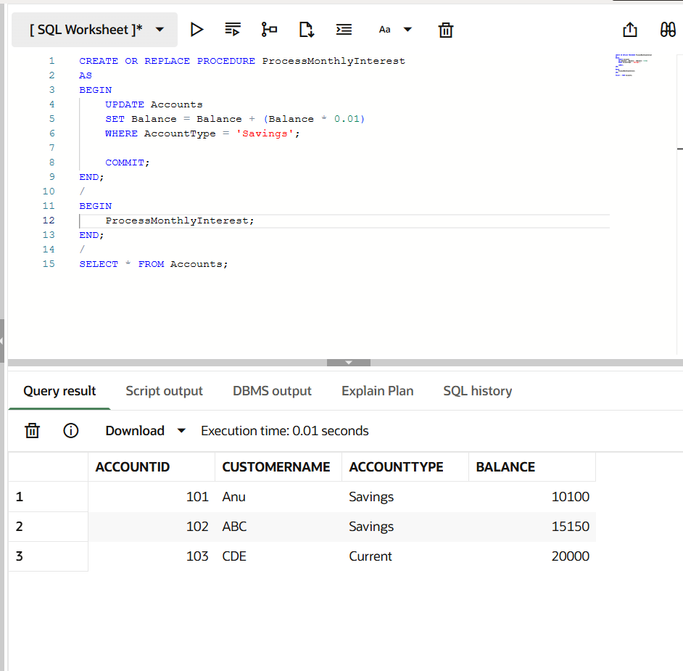

Scenario 2: Update Employee Bonus
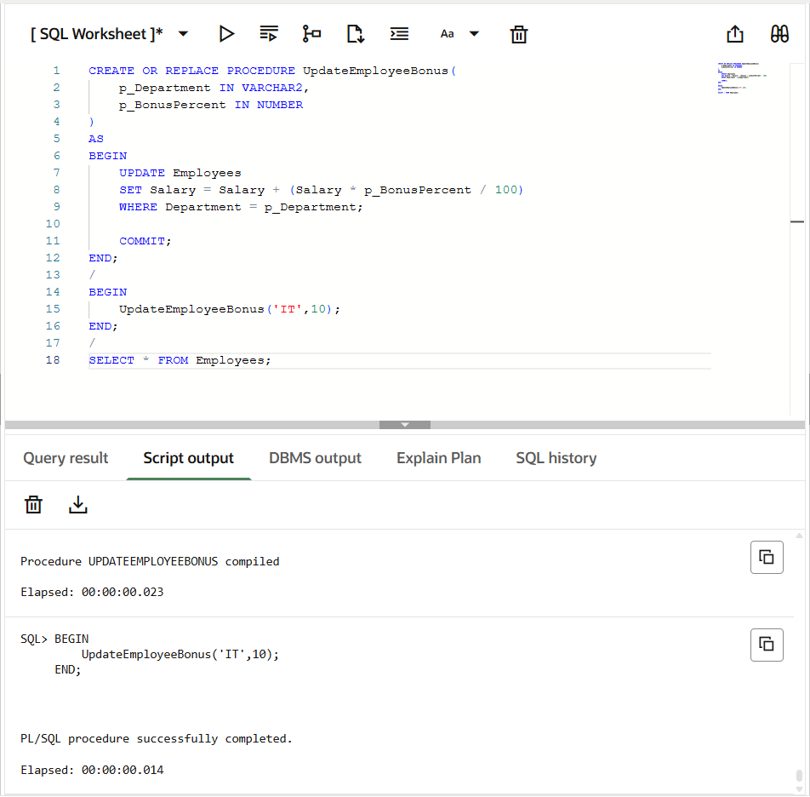
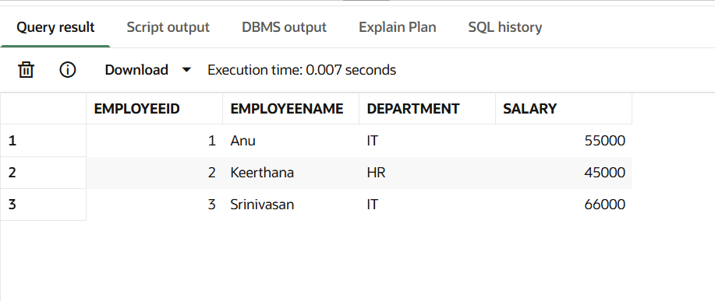
Scenario 3: Transfer Funds
